DAY 4 LAB EXPERIMENTS

NAME : L ARAVIND
Reg No : 192424080
DATE : 19/12/2025

EXP_16 Write a Python program to compute the frequency distribution of words from a product’s customer reviews dataset.
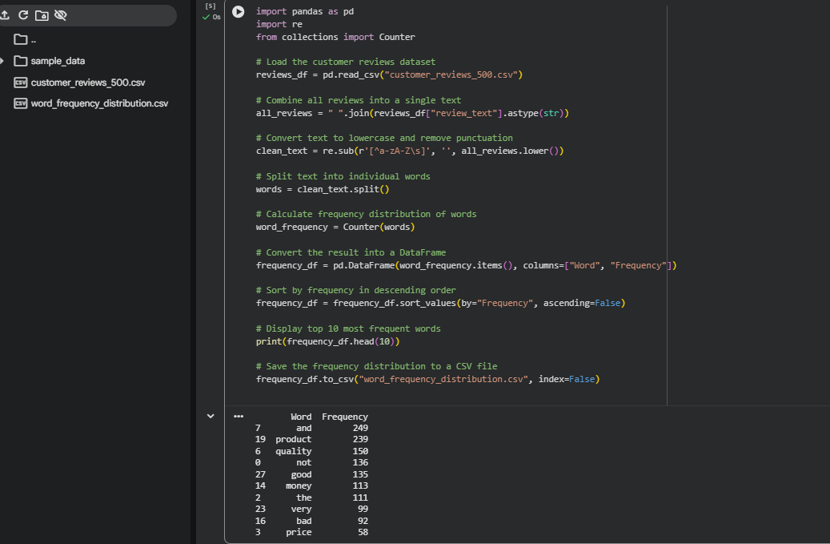

EXP_17 Develop a Python program to preprocess customer feedback from a CSV file, compute word frequencies, display the top N words, and visualize them using a bar chart.
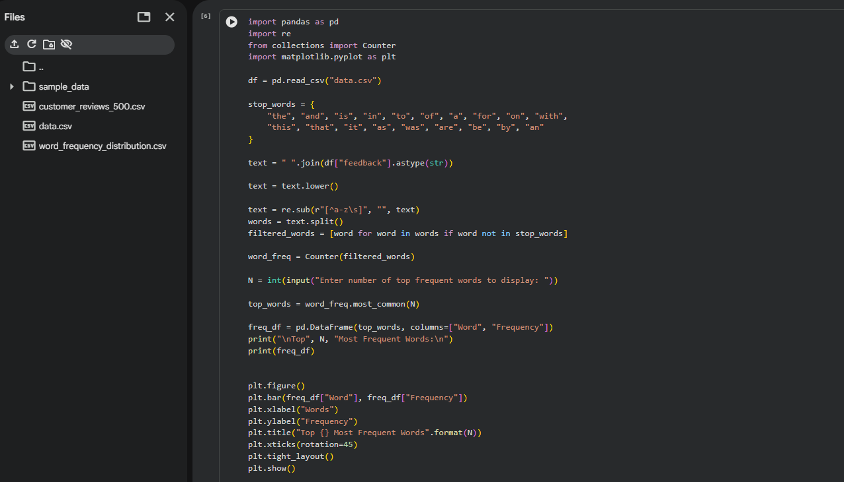
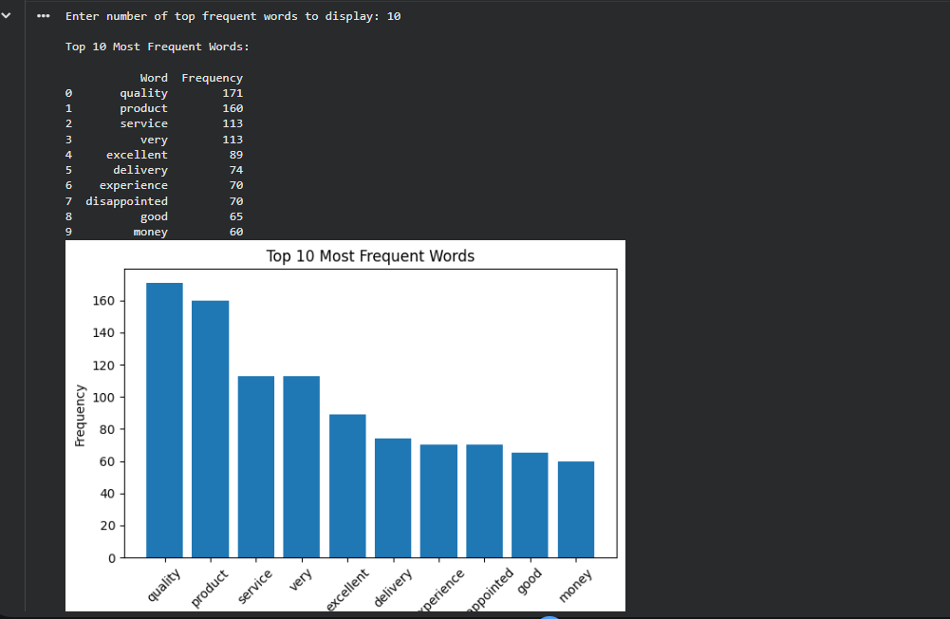

EXP_18 Use Pandas to calculate mean, median, and standard deviation of age and body fat data, and visualize them using boxplots, scatter plots, and Q–Q plots.
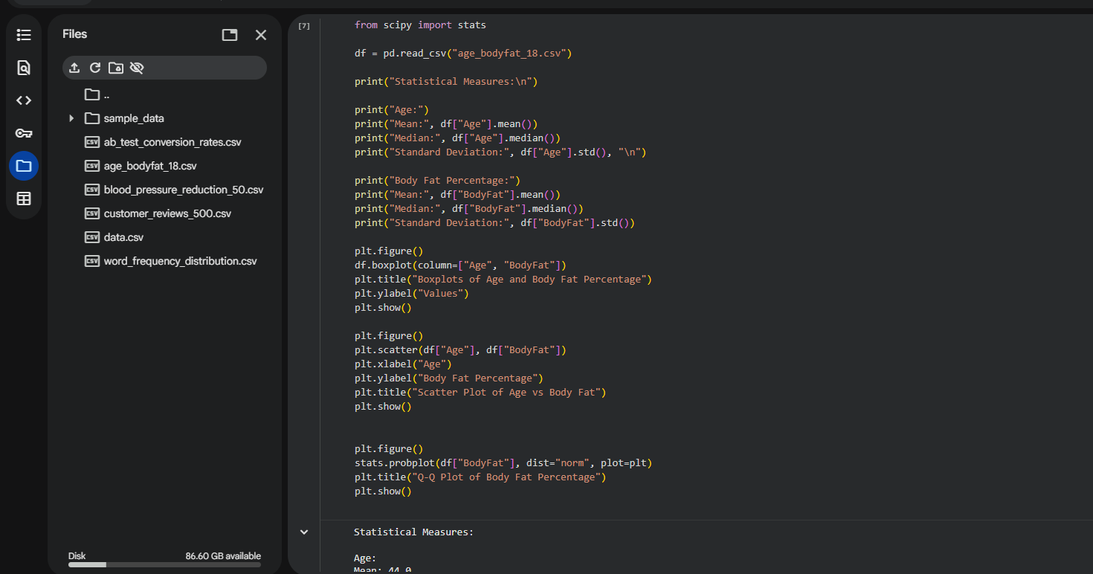
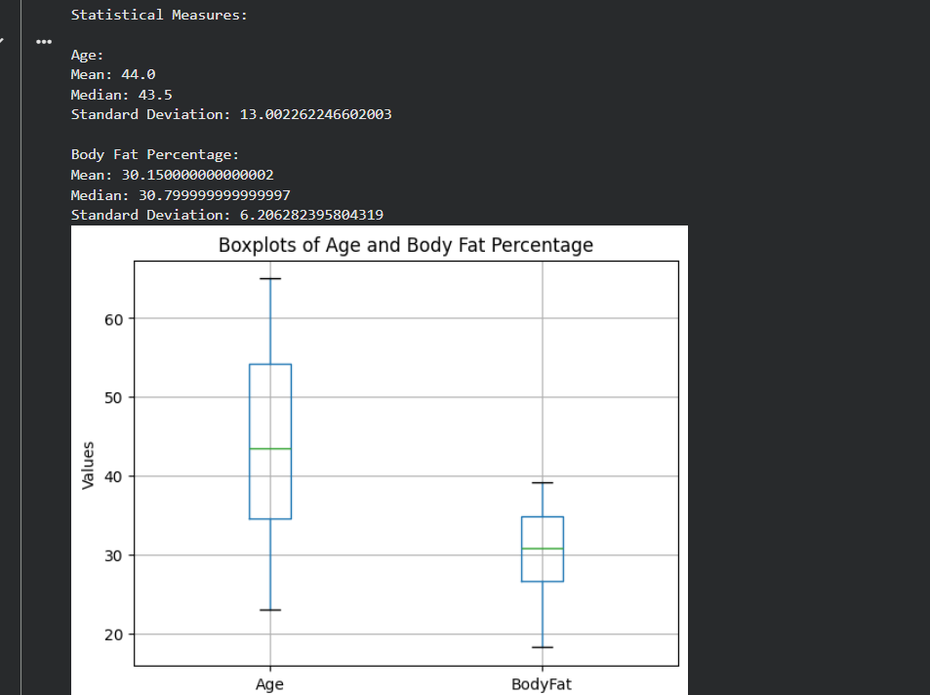

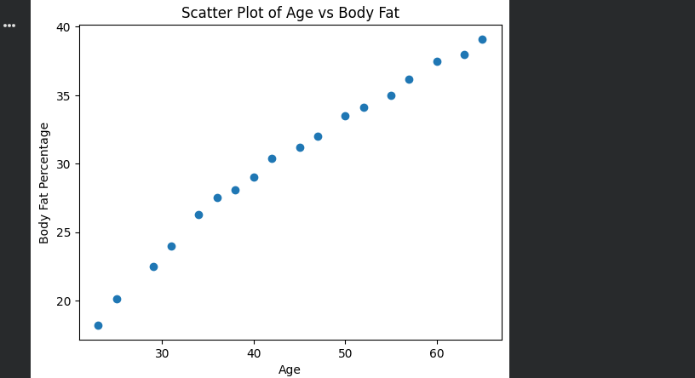
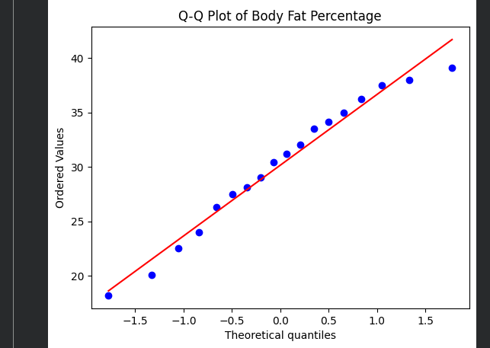

EXP_19 Calculate the 95% confidence intervals for the mean blood pressure reduction in both drug and placebo groups from a clinical trial.
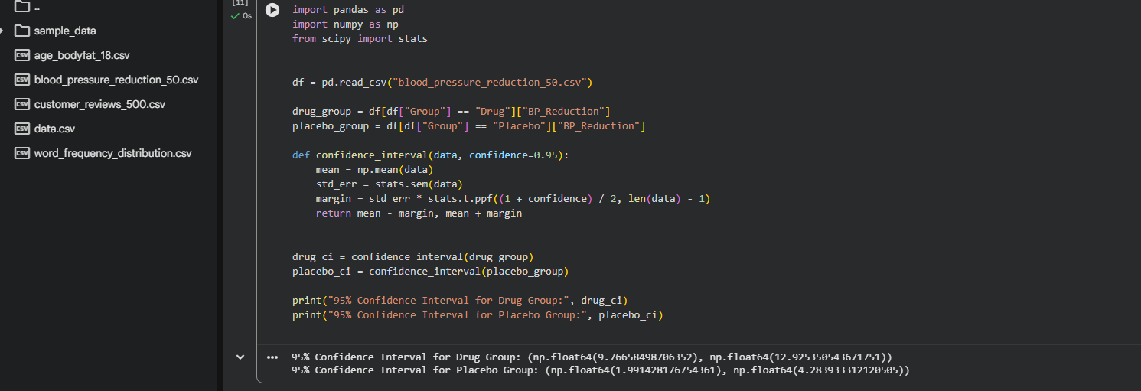
EXP_20 Analyze A/B test conversion rate data to determine whether there is a statistically significant difference between website designs A and B.
